Whitepaper - Instrumentation

Abstract

This paper describes a common strategy for adding instrumentation (logging, tracing and performance monitoring) to Microsoft .NET applications.

Event types

Instrumentation needs to support different levels of operation, from high performance production systems through to developmental debugging.

Several levels of event type are possible, this framework categorises them into seven types with increasing detail. The structure of the levels can be considered a pyramid, with each level having less importance but more volume.

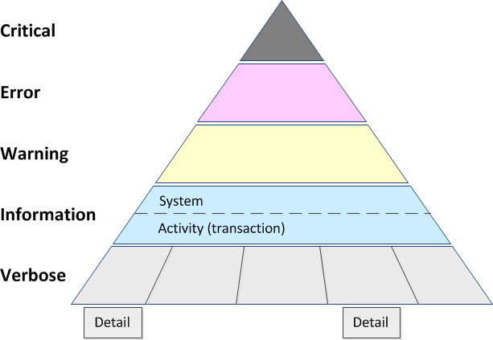

There should be few (hopefully none) critical events, maybe a few errors, and hopefully more warnings than errors; information events (system and activity) should be relatively regular occurrences, but not an overwhelming volume, while there would be a large volume of verbose and more detailed tracing – if it was all turned on at once.

For a production system usually only the first four levels are monitored, using a combination of the Windows Event Log, Windows Performance Monitor, and application-specific log files. Usually you want all of these events to be reported; it seldom makes sense to turn off errors or critical events.

Around the information level the volume of information starts to increase; while some information events, like the start or stop of a service, are usually reported in the Windows Event Log, more frequent events, such as logging of each request for a web server, usually use an application-specific structured log.

The more detailed verbose events are usually only part of the applications tracing strategy, and only when tracing is enabled. The tracing also includes the other levels of event, as reference points, but may include more detail.

Turning on all verbose events as a single level would usually result in an overwhelming volume of information, so it is common to partition this level up into separate functions that can be individual turned on or off, e.g. a separate TraceSource for each area.

For particular low level and high volume detailed information, it may be necessary to have even individual control flags (BooleanSwitch) whether to trace or not, e.g. writing full request/response details to the trace.

Your application may have a different set of levels, for example SharePoint has Critical, Warning, Unexpected, Monitorable, Information, High, Medium, Verbose, and VerboseEx, but the general principal of increasing detail and volume of messages at each level still applies.

Event type table

Type | Description | Logging | Monitoring | Tracing
Critical | System or task permanent failure. At system level the system is not functioning; at task level the task has failed. In some cases a task level error may be considered a system level warning. | Windows event log (Error) |  | SourceSwitch*
Error |  | Windows event log (Error) | Errors/sec | SourceSwitch*
Warning | System or task temporary/partial failure. Task or component will be re-attempted or continue. Also for true warnings (almost failures), e.g. a resource is running low. | Windows event log (Warning) | Resource level (where appropriate) | SourceSwitch*
Information | Successful system events. e.g. start, stop, other significant one-off or rare events. | Windows event log (Information) |  | SourceSwitch*
Activities | Successful tasks, usually expected to be repeated multiple times. e.g. each transaction or each message processed. | Application log | Trans./sec  Total trans. | SourceSwitch with Activity Tracing (start, stop, etc)
Verbose | System/task major steps to identify areas for further investigation (debug information); should not produce more detail than can be handled manually. |  |  | SourceSwitch
Detail | Detail steps within a task; rather than overwhelm a trace file with details, tracing at this level should be broken up into multiple parallel Boolean Switches. |  |  | BooleanSwitch
* Note: Normally a SourceSwitch will be turned on with at least Information level of logging.

Your application may have a different set of levels, for example SharePoint has Critical, Warning, Unexpected, Monitorable, Information, High, Medium, Verbose, and VerboseEx, but the general principal of increasing detail and volume of messages at each level still applies.

Considerations for logging to the Windows event log

- An application should use a consistent Windows event log “Source”. If the application is a Windows Service, then the service name should be used as the event log source. Otherwise, the application name (as it appears in Windows) should be used.
This value should be a constant defined in the application, so that the values are always consistent.
Note that you need to install event log sources (as administrator) before they can be used.

- The type of event should correspond to the event type.

- Unlike tracing, writing to the Windows event log does not need to be configurable, i.e. write directly to the Windows event log and do not rely on a particular system.diagnostics tracing configuration.

- Consistently write trace events at the same time you write to the Windows event log and update performance monitor counters. This provides context and allows the Windows event log to be correlated with the trace file (consider putting the trace correlation identifier in the Windows event log).

Considerations for application log formats

- Application specific logs should contain transaction details – one log entry for each transaction the application completes, e.g. each message processed.

- Common formats are either a structured text file or database.

- If written to a text file, it should be assumed that the file will be imported into a database, spreadsheet, or other application for processing.

- If written to a database, the application should support generic OLEDB for any database system (i.e. not Microsoft SQL Server specific).

- Application logs can contain transactions only, or the same log may also contain other events, such as error, warnings, and system information events (i.e. multiple event types).

- Logs should contain timestamps. These may be auto generated, but should be consistent between text and database log types. Timestamps in text files should use the ISO format, e.g. “2004-03-09T04:01:44”.

- Logs should contain server name. Even if written to a text file, usually logs will be imported into a central application.

- If supporting multiple events, the log should identify the event type: Error, Warning, Information, with transactions having blank or a value like “-“ in a text file. (You would not normally include activity tracing or verbose traces in an application log file.)

- If also logged to the Event Log (i.e. is an Error, etc), then the values in the event log should be consistent with those in the application log.

- If the application supports multiple users, then the current user (IPrincipal.Identity.Name) may be logged.

- Application log files are application specific, so Windows Event Log-like “Source” (application name) is not required.

- If relevant, numeric Category and Event ID, corresponding to the Event Log, may be used. Usually textual information is more useful, however.

- Other details logged are application specific description, binary data, etc.

- If using a text file, the file should be TAB separated, with <TAB> as a field separator, and new line (either <CR>, <LF>, or <CR><LF>) used as a record separator. These characters should never appear elsewhere on a line. (A comma delimited file is also possible, but you then need to handle any commas in textual data).

- Text files should be output in UTF-8, providing full support for ASCII, and support for Unicode with an appropriate text editor.

- The majority of fields may contain data – dates, numbers, tokens, URI’s, etc, and do not need special processing. Any potential fields that contain user-input, however, may contain embedded new lines, tabs, and other control characters, and should be escaped.
e.g. Any control characters (U+0000 – U+001F) can be encoded as %00, %01, %02, etc, to use the URL encoding scheme (an alternative could be ^@, ^A, ^B, etc).
Encoding ensures that there are no embedded control characters, and the TAB delimited file can be safely processed by any supporting application, yet still easily read with a text editor if necessary. Using an encoding, rather than simply removing the characters, also makes it clear where such characters are present, even though display may be a little unsightly. Such control characters should be rare, and the logs files should be suitable without decoding.

Considerations when tracing

- Trace information should usually be written to text files. They should not clutter up the Windows Event Log, and are too unstructured, and usually don’t warrant the effort of building a database.

- Trace files are designed to aid debugging and troubleshooting. They are viewed using a text editor, and do not need to be specially formatted for importing or processing.

- Files should be output in UTF-8, providing full support for ASCII, and support for Unicode with an appropriate text editor.

- Trace listener should provide rolling capability, to keep long running trace files at manageable size.

- Trace files should contain a timestamp. This can be added by the trace listener. Timestamps should use the ISO format, e.g. “2004-03-09T04:01:44”.

- The thread hash may be useful in some multithreaded applications. This can be added by the trace listener.

- Trace files are usually specific to a single server, so no server parameter is required.

- Indenting is not very useful, particularly for multi-threaded apps, and should not be used.

- Values written may include embedded new lines, resulting in multi-line output. This is useful for dumping out blocks of XML, hex bytes, etc.

- Preferably, it should be possible to enable/disable tracing without restarting the application/service, although this is not possible using the built-in .NET tracing framework, which only reads the config file at startup.

